# Q2) Difference between FHSS and DSSS

FHSS (Frequency Hopping Spread Spectrum) and DSSS (Direct Sequence Spread Spectrum) are two wireless data transmission technologies that belong to the spread spectrum communication class. Both FHSS and DSSS can be used to improve the security and dependability of wireless signals. In this article, we will discuss the differences between Frequency Hopping Spread Spectrum (FHSS) and Direct Sequence Spread Spectrum (DSSS).

## FHSS (Frequency-Hopping Spread Spectrum)

FHSS is a wireless communication technique where the carrier frequency rapidly changes among many frequencies within a large spectral band. This frequency hopping is controlled by a code known to both the transmitter and receiver. FHSS is a type of multiplexing, which allows multiple signals to be transmitted simultaneously over a shared channel.

## Advantages of FHSS

* **Robust Transmission Path**: FHSS provides a very robust transmission path even in the presence of interferences such as multipath, noise, and other [wireless transmissions](https://www.geeksforgeeks.org/different-types-of-wireless-communication-media/). This robustness is due to its support of wide bandwidth.
* **Point-to-Multipoint Applications**: FHSS can be effectively employed in point-to-multipoint scenarios, allowing multiple devices to communicate with a central [hub](https://www.geeksforgeeks.org/network-devices-hub-repeater-bridge-switch-router-gateways/) or access point.
* **Minimal Interference**: It supports about ten nearby WLAN-compliant Access Points (APs) without significant interference issues.
* **Security**: FHSS ensures security against intrusion since only the transmitter and receiver are aware of the Pseudonoise (PN) codes used for frequency hopping.

## Disadvantages of FHSS

* **Bursty Errors**: As FHSS relies on carrier frequencies to transmit information bits, it can lead to strong [bursty errors](https://www.geeksforgeeks.org/types-of-errors-in-computer-network/" \t "_blank) due to frequency-selective fading.
* **Lower Data Rate**: FHSS supports a lower data rate (around 3 Mbps) compared to the 11 Mbps supported by Direct-Sequence Spread Spectrum (DSSS).
* **Coverage Range**: It has a lower coverage range due to the high Signal-to-Noise Ratio (SNR) requirement at the receiver.
* **Obsolete Modulation Scheme**: FHSS has become less common due to the emergence of newer wireless technologies in consumer products.

## Applications of FHSS

* FHSS is used in[Bluetooth](https://www.geeksforgeeks.org/bluetooth/)
* Military Communications
* Walkie-Talkies
* [Wireless Local Area Networks (WLANs)](https://www.geeksforgeeks.org/wlan-full-form/)
* Remote Controls

## DSSS (Direct-Sequence Spread Spectrum)

In DSSS (Direct-Sequence Spread Spectrum), the data to be transmitted is first encoded using a “chip code.” The chip code is used to [modulate](https://www.geeksforgeeks.org/what-is-modulation/) the carrier signal, spreading the transmitted signal across multiple frequency bands. The receiver uses the same chip code to demodulate the received signal, allowing it to recover the original data. DSSS is that it is relatively easy to implement and requires less complex equipment.

## Advantages of DSSS

* **Interference Minimization**: DSSS uses both time and frequency planes to transmit information bits. This minimizes the impact of interference and fading, making it robust in challenging environments.
* **Point-to-Point Applications**: DSSS can be effectively employed in [point-to-point](https://www.geeksforgeeks.org/differences-between-point-to-point-and-multi-point-communication/) scenarios, achieving a data rate of about 11 Mbps.
* **Coverage Range**: It supports a higher coverage range due to its low Signal-to-Noise Ratio (SNR) requirement at the receiver

## Disadvantages of DSSS

* **Sensitivity to Harsh Environments**: DSSS is sensitive to harsh conditions such as collocated cells, larger coverage areas, and multipath interference. Its narrow bandwidth operation makes it vulnerable.
* **Error Sensitivity**: DSSS is more prone to errors at lower levels compared to Frequency-Hopping Spread Spectrum (FHSS).
* **Bandwidth:** The channel [bandwidth](https://www.geeksforgeeks.org/what-is-bandwidth-definition-working-importance-uses/) required is very large.

## Applications of DSSS

* [GPS (Global Positioning System)](https://www.geeksforgeeks.org/how-gps-works/)
* [CDMA (Code Division Multiple Access)](https://www.geeksforgeeks.org/cdma-full-form/) Cellular Networks
* Satellite Communication
* Wireless Sensor Networks

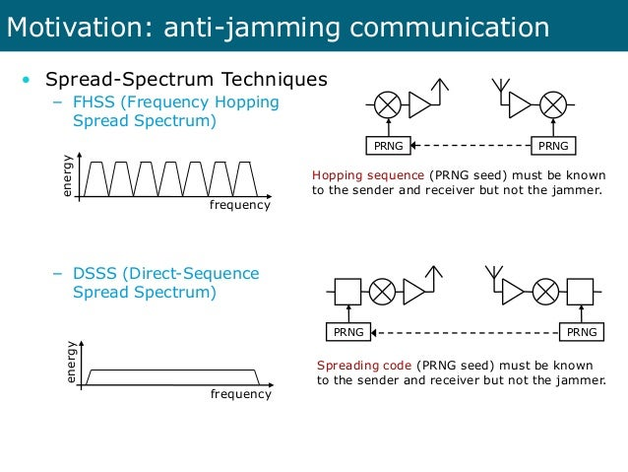

## Differences between FHSS and DSSS

|  |  |  |
| --- | --- | --- |
| Category | FHSS | DSSS |
| Abbreviation | FHSS is Frequency-Hopping Spread Spectrum | DSSS is Direct-Sequence Spread Spectrum |
| Definition | FHSS is a type of spread spectrum technology in which the frequency of the transmitted signal changes according to a specific pattern. | DSSS is a type of spread spectrum technology in which the transmitted signal is spread across multiple frequency bands. |
| Pattern | In FHSS, the data transmission is encoded and decoded using a specific pattern called **hopset**. | In DSSS, the data transmission is encoded and decoded using a pseudo-random binary sequence or **chip**code. |
| Frequency band | FHSS transmits data using a narrowband carrier that hops among different frequency channels. | DSSS transmits data using a wider frequency band. |
| Interference resistant | FHSS is more resistant to interference because it uses frequency hopping, which makes it difficult to intercept the signal. | DSSS is more vulnerable to interference because it uses a wider frequency band. |
| Susceptibility | FHSS is less susceptible to multipath fading, it is a phenomenon in which the transmitted signal arrives at the receiver via multiple paths, resulting in a loss of signal quality. | DSSS is more susceptible to multipath fading because it uses a wider frequency band. |
| Transmission speed | FHSS has low transmission rates (up to 3 Mbps). | DSSS has high transmission rates (up to 11 Mbps). |
| Modulation techniques used | Multilevel Frequency Shift Keying (FSK) was used. | BPSK (Binary Phase-Shift Keying) was used. |
| Efficiency | FHSS is generally more efficient than DSSS in terms of bandwidth utilization. | DSSS is less efficient because it uses a wider frequency band. |
| Application areas | It is widely used in a variety of applications, including wireless networking like Bluetooth, mobile communications, and military communications. | It is well-suited for particular applications where the signal must travel over long distances like GPS, and WIFI. |